DAY 3: INTRODUCTION TO IP ADDRESSING THEROY

- List the key differences between IPv4 and IPv6 addressing by creating a two-column table with at least 4 points for each.
Answer
IPv4 vs IPv6 Addressing – Key Differences
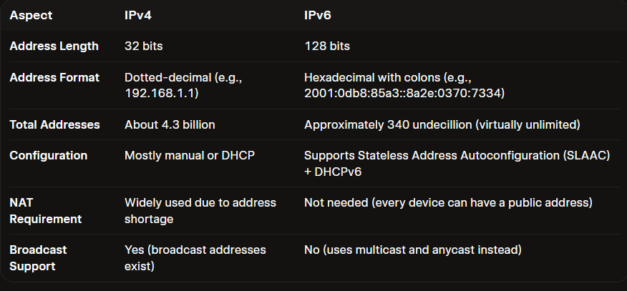

- Given the following scenario: You have 4 devices (laptop, phone, smart TV, and printer) connected to your home Wi-Fi. Assign a unique static IPv4 address to each device using the 192.168.10.0/24 network, and write down the IP, subnet mask, and default gateway for each device.
Answer
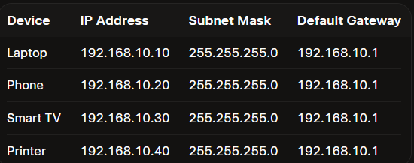
Notes:
- All devices use the same subnet mask (255.255.255.0) because they are on the same /24 network.
- The default gateway (192.168.10.1) is normally the IP address of your home Wi-Fi router.
- I left some gaps between the addresses (10, 20, 30, 40) so you can easily add more devices later if needed.

- Calculate the number of valid subnets and hosts per subnet if you use a /27 CIDR subnet mask on a 192.168.1.0 network. List the first three valid subnet address ranges (network address to broadcast address) and the usable host IPs in each.
Answer
Subnetting Calculation: 192.168.1.0 with /27 mask
- CIDR: /27
- Subnet Mask: 255.255.255.224
- Bits borrowed (from a /24): 3
- Number of valid subnets: $2^{3}=8$
- Hosts per subnet: $2^{5}-2=30$usable hosts
- Block size / Increment: 32
First Three Valid Subnets
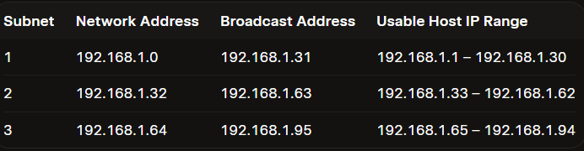

- You are given the IP address 10.0.5.17 with subnet mask 255.255.255.0. Determine the network address, broadcast address, and the range of valid host addresses for this subnet. Convert the subnet mask to CIDR notation and use bitwise AND for network address calculation.
Answer
Given:
- IP Address: 10.0.5.17
- Subnet Mask: 255.255.255.0 → CIDR: /24
Calculation
- Network Address
Perform bitwise AND between the IP and the subnet mask:
10.0.5.17 AND 255.255.255.0 = 10.0.5.0
- Broadcast Address
All host bits set to 1:
10.0.5.255
- Valid Host Address Range
From network address + 1 to broadcast address – 1:
10.0.5.1 – 10.0.5.254
Summary
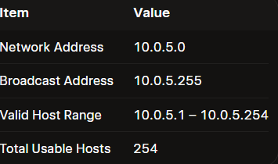

- Use an online subnet calculator tool (such as https://www.subnet-calculator.com/) to verify your answer for the previous task. Take a screenshot of your calculation and write one line explaining if your manual answer matched the tool's output.
Answer
You can verify it using the subnet calculator, but I can’t take a screenshot of your browser from here.
Open the calculator and enter:
- IP address: 10.0.5.17
- Subnet mask: 255.255.255.0 or /24
The expected output is:
- Network: 10.0.5.0
- Broadcast: 10.0.5.255
- Usable hosts: 10.0.5.1 – 10.0.5.254
For your assignment, take a screenshot showing these results and add:
The manual calculation matched the subnet calculator’s output exactly.

